**USER INSTALLATION GUIDE**

Farmer Supermarket project is a web application developed using the PHP scripting language. XAMPP server must be installed on the system to run the project as it is a cross-platform web server which has an Apache HTTP server, MYSQL to handle the database and has interpreters to run the PHP script.

**Step 1:**

* To download the XAMPP server visit the link <https://www.apachefriends.org/download.html>

**Step 2:**

* Choose the latest version of XAMPP for Windows( PHP 7.4.6 )

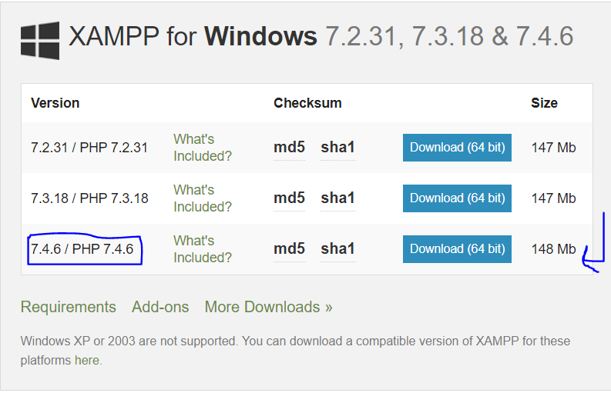

**Step 3:**

* On clicking the download button, you will be redirected to the other webpage <https://www.apachefriends.org/download_success.html>
* The executable file with the extension ( .exe ) will start downloading automatically.

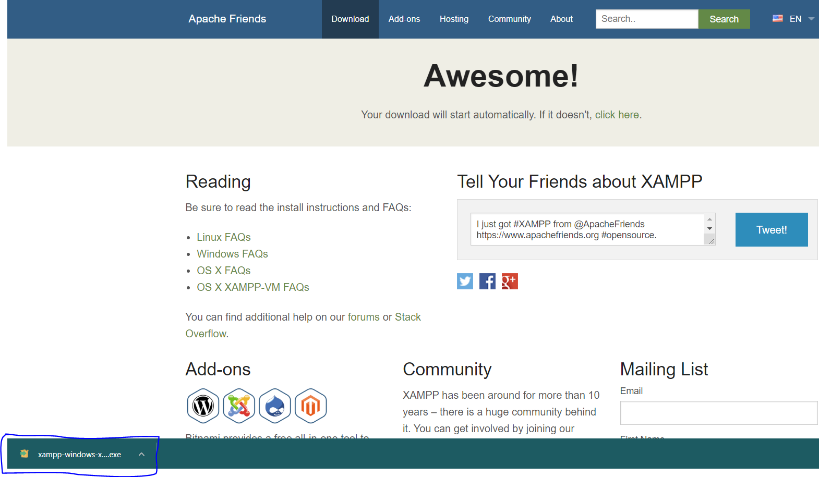

**Step 4:**

* Double click on the executable file once the download is finished. When the system asks permission to make the changes on the system click on the **Yes** button, that allows the system to install the XAMPP.
* If this warning pops up then the click **OK.**

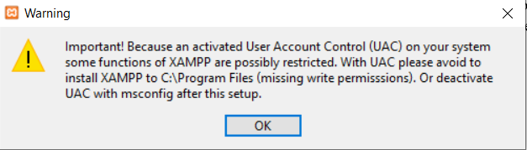

* Type msconfig in the windows search and open the application.

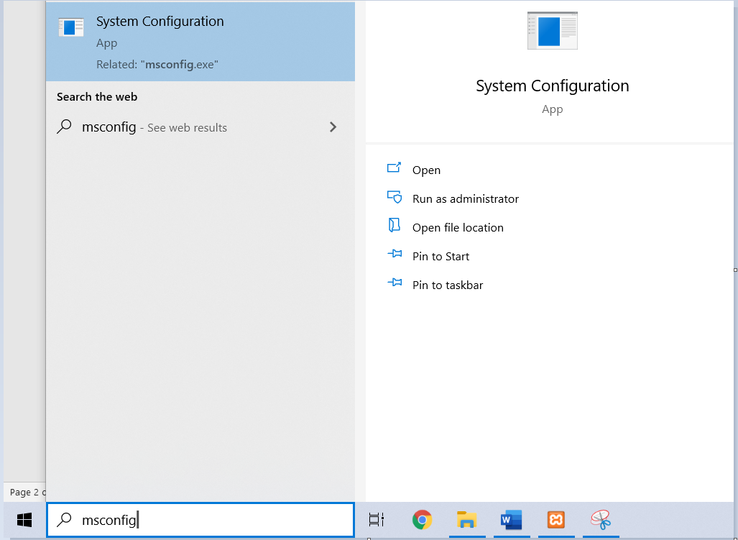

* Navigate to the Tools tab and select **change UAC settings** and click on the launch button.

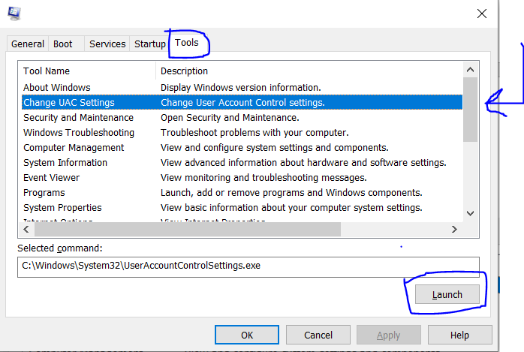

* Drag the slider to never notify and then click **OK** button.

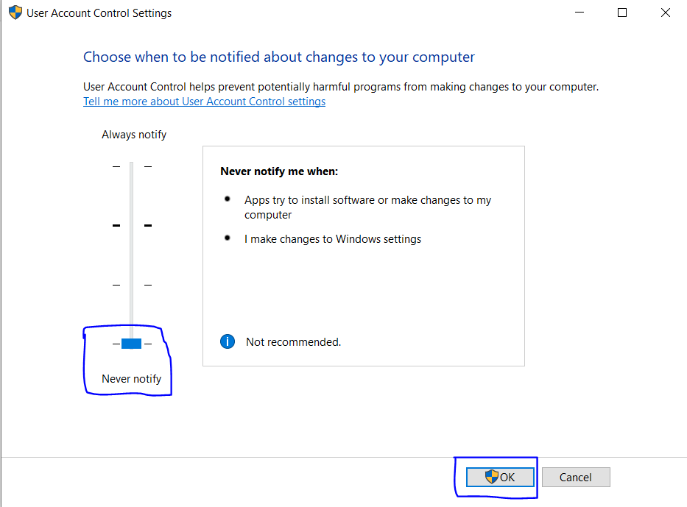

**Step 5:**

* Once the application popup is displayed, click on next to proceed for installation. Follow the setup instructions given below.

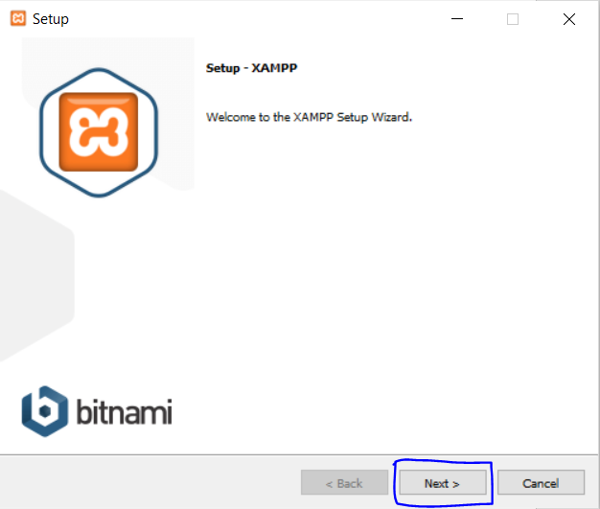

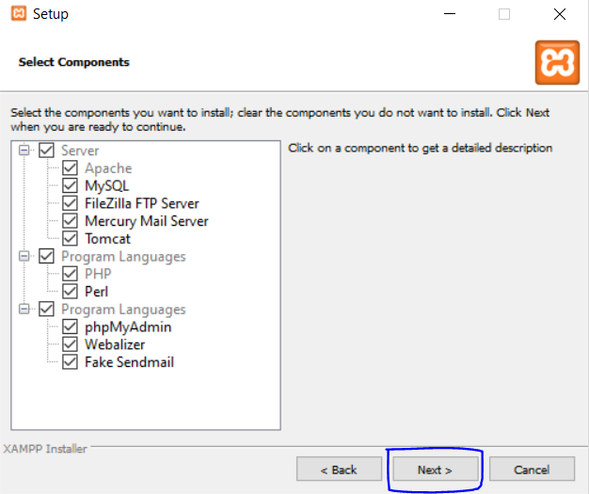

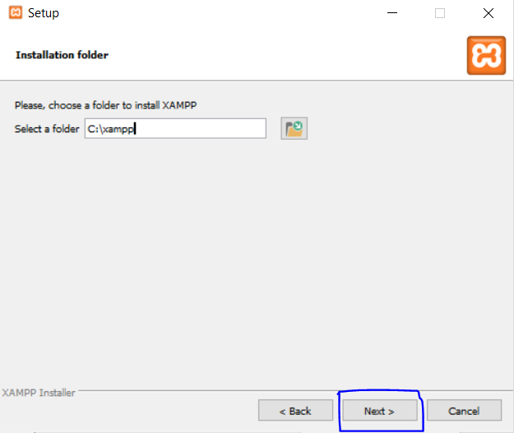

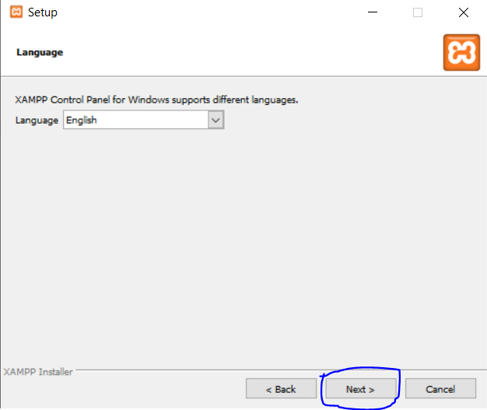

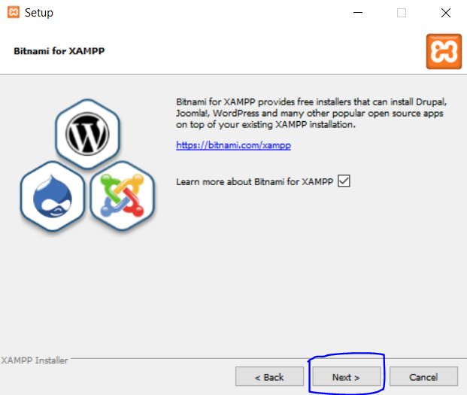

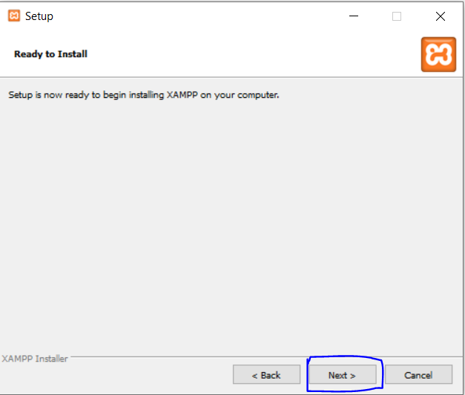

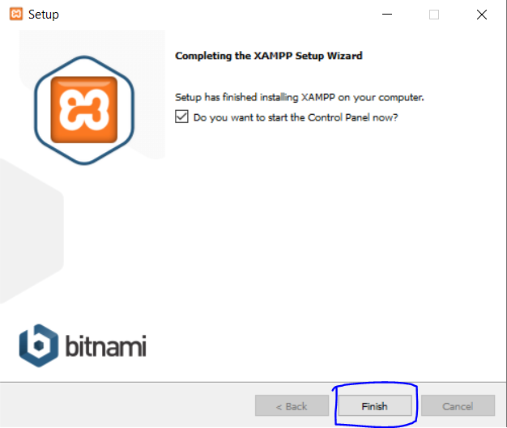

**Step 6:**

* Once the finish button is clicked then the XAMPP control will be opened.
* Click start buttons on **Apache and MySQL** to start running the PHP scripts and database.

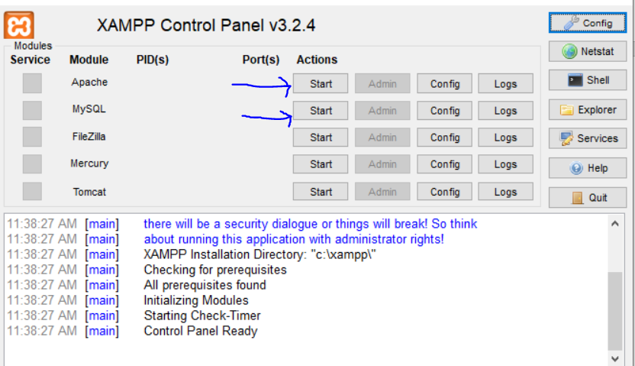

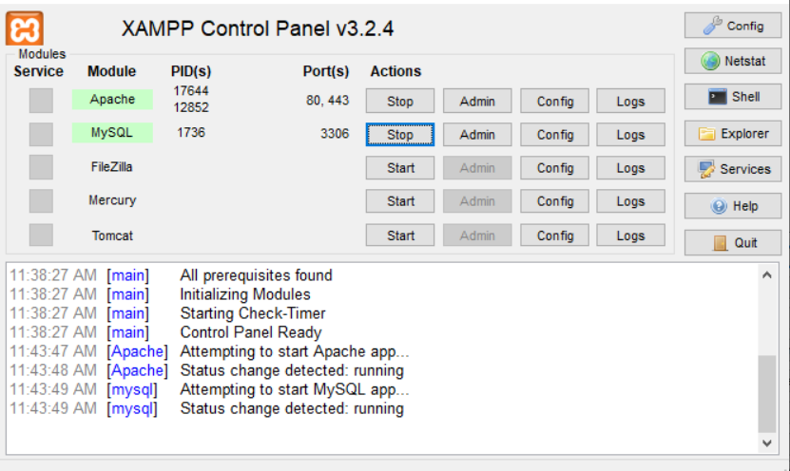

**Step 7:**

* To run the project, download the project file from the github.
* Go to the downloads, check the file and extract the project folder.

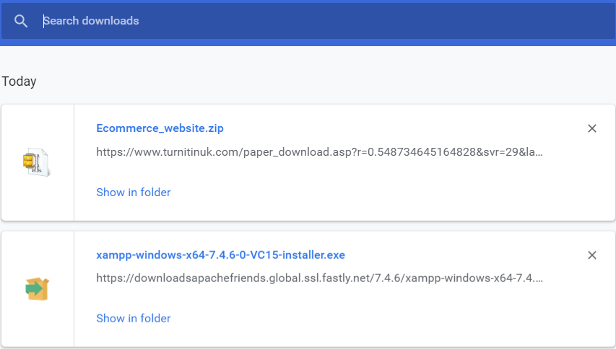

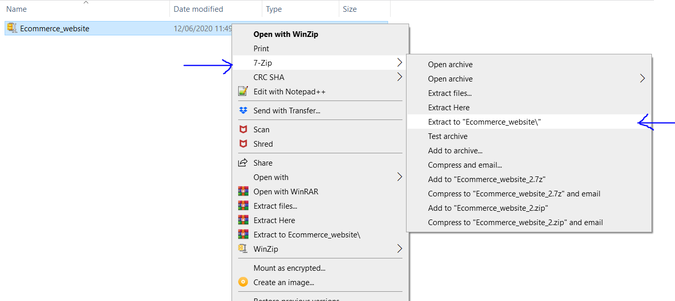

* Copy the folder from the file location and place it in **C:\xampp\htdocs** folder location.

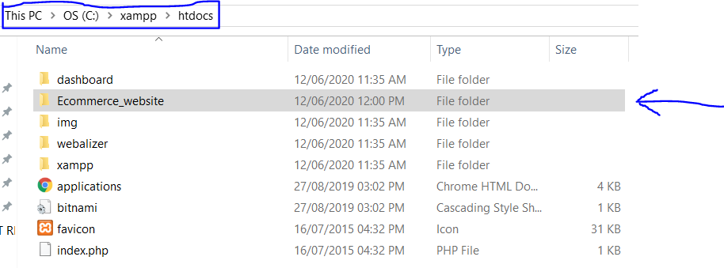

**Step 8:**

* Database has to be imported for loading the data in the application. So as to do that type <http://localhost/phpmyadmin/> in the browser.
* Create a database to store all the information of the project. Name the database as **db_ecommerce** and click on create button.

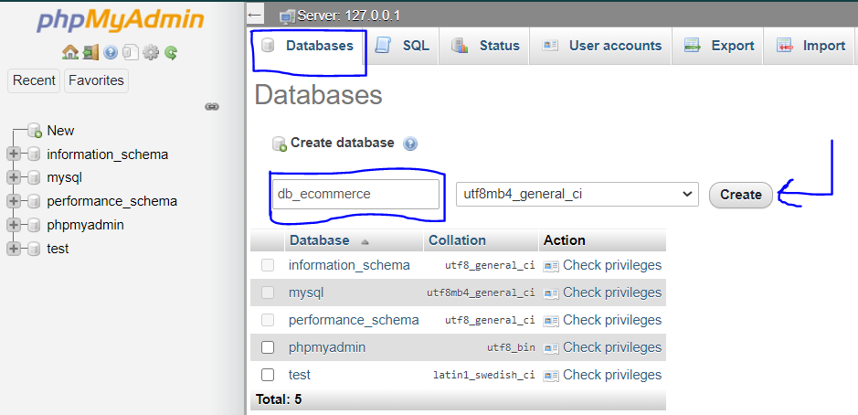

* Once the database is created then click on the **import tab** displayed at the top of the browser to load all the tables from the **db_ecommerce.sql** file.

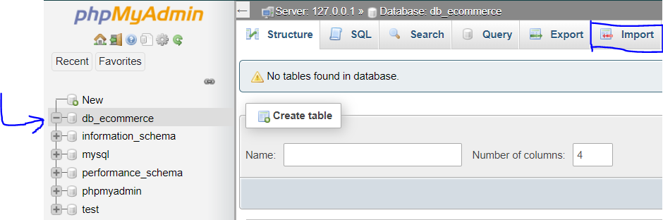

* Once you click on the import tab following webpage is displayed.

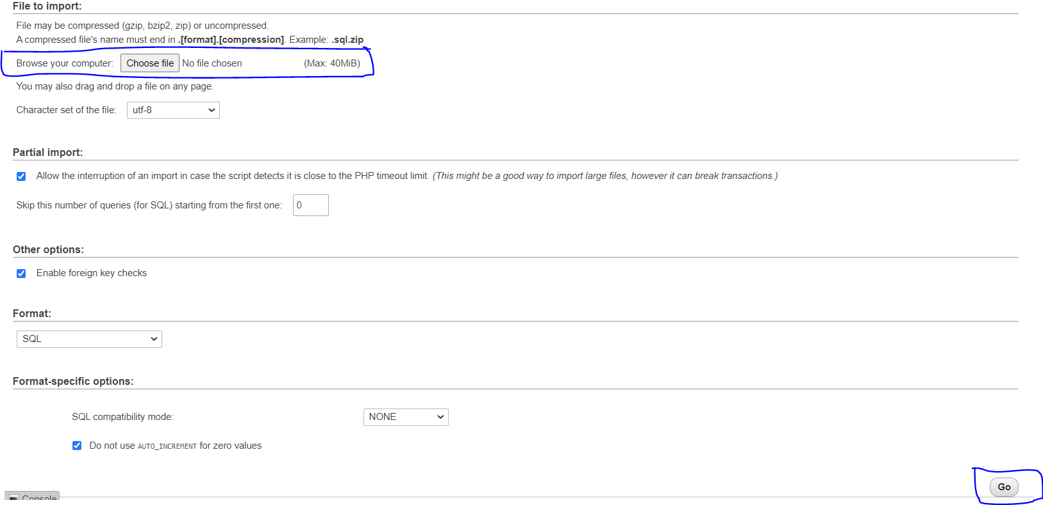

* Choose the **db_ecommerce.sql** file from the **C:\xampp\htdocs\Ecommerce_website**

Folder location and then click on **Go** button.

* Data will be loaded and success message will be displayed on the webpage.

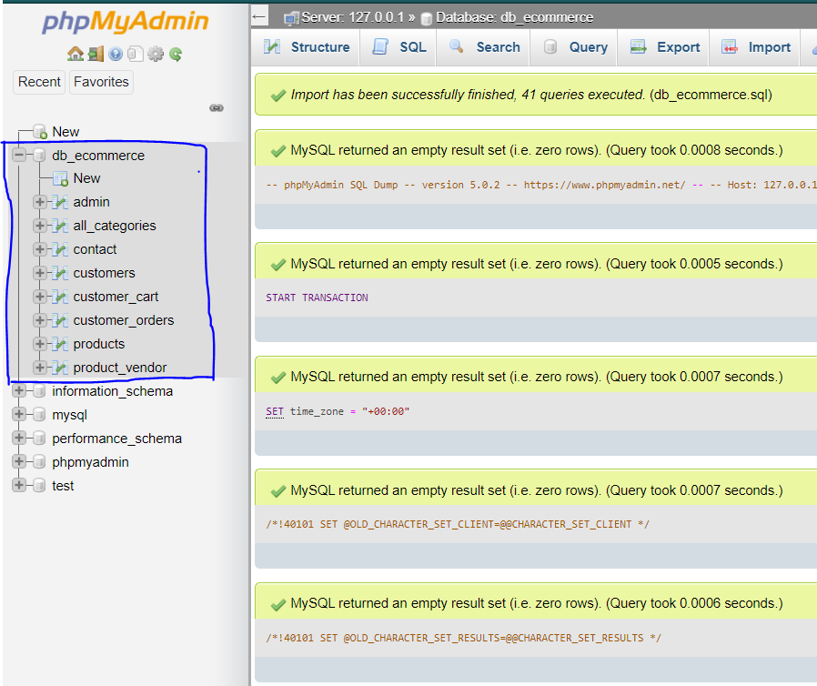

**Step 9:**

* Now open the browser and type the URL <http://localhost/Ecommerce_website/> and click enter to open the project.
* Once the project is opened then the index webpage is displayed. Below image shows the index webpage of the project.

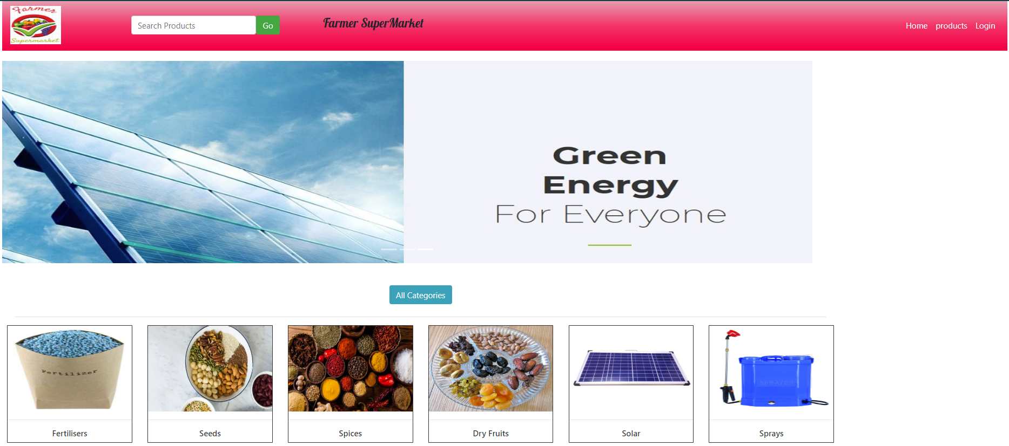

**Step 10:**

* To stop or start the XAMPP services **xampp-control** application is found in the **C:\xampp** folder location.

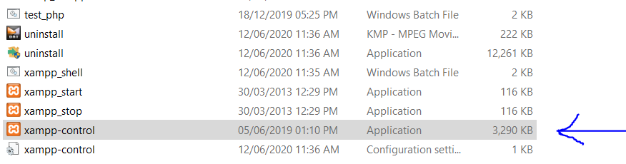

* When it is doubled clicked then the following application is opened where the services can be started and stopped. This makes the XAMPP server to **ON** or **OFF** its services.

